Here are the specific tasks to be completed:

-Create a Content Recommendation System (CRS) on AWS. Design and develop a system that can recommend relevant content to users based on their preferences and behaviors. Utilize AWS services and technologies to build an efficient and scalable CRS solution.

-Prepare a report that outlines the working of the CRS. Explain the underlying algorithms, data processing techniques, and the overall workflow of the system. Describe how user preferences and behavior are captured and how recommendations are generated.

-Devise an efficient and cost-effective implementation plan for the CRS on AWS. Consider factors such as scalability, performance, cost optimization, and the utilization of AWS services to achieve the desired outcomes.

-Identify and describe the AWS services that will be used to build and operate the CRS. This may include services like Amazon S3 for data storage, Amazon EC2 for hosting the application, Amazon DynamoDB for database management, Amazon Personalize for recommendation algorithms, and more.

-Research and provide a detailed report on existing Content Recommendation Systems. Choose one system as an example and provide an in-depth analysis of its features, architecture, algorithms employed, and the overall effectiveness of the system.

-Create a comprehensive PowerPoint presentation (PPT) and report that covers all the above points. Include relevant diagrams, data, and analysis to support the understanding of CRS, its AWS implementation, services used, and examples of existing systems.

Ensure effective collaboration among team members and adhere to the given deadline. Submit the completed task in the form of a Google Drive folder link, providing access to the link for facilitation.

* Gunjan
* Subham
* Harish

[Subham Singh](mailto:subam9383@gmail.com)

**Amazon S3:** This service provides object storage in the cloud. You can use S3 to store and retrieve any amount of data from anywhere on the web.

**Amazon IAM:** With AWS Identity and Access Management (IAM), you can specify who or what can access services and resources in AWS, centrally manage fine-grained permissions, and analyse access to refine permissions across AWS.

**AWS Personalize:** Amazon Personalise uses your data to train domain-based or customizable recommendation models. You use a private recommendation API in your application to request real-time recommendations. Amazon Personalise also supports batch workflows to get item recommendations and user segments.

## **Amazon SageMaker:** Amazon SageMaker is a cloud based machine-learning platform that enables developers to create, train, and deploy machine-learning models on the cloud. It also enables developers to deploy ML models on embedded systems and edge-devices.

**Amazon EC2:** This service provides scalable computing capacity in the cloud. You can use

EC2 to host your application and manage your virtual machines.

[Sooriya -A](mailto:sooriyareading@gmail.com)

**Cost Optimization** - AWS Cost Explorer is a tool in the AWS Cost Management service. It helps you visualise your costs and usage associated with AWS services. The tool provides a default report that displays your top-five cost-accruing AWS services. This report is an excellent place to start your cost optimization efforts.

**Scalability** - Your AWS cost-reduction exercise should reduce the amount of resources needed to support your applications, leading to improved scalability. As you optimise, you can consolidate resources and reduce waste. The deepest discounts typically require long-term planning. By going through that exercise, you can dedicate resources for future use as you grow. As you continue to save money by optimising costs, you can reinvest more of your budget into business growth.

**Performance** - The Performance Efficiency pillar includes the ability to use computing resources efficiently to meet system requirements, and to maintain that efficiency as demand changes and technologies evolve. The performance efficiency pillar provides an overview of design principles, best practices, and questions.

**Utilisation of AWS** - The AWS Professional Services organisation is a global team of experts that can help you realise your desired business outcomes when using the AWS Cloud.

[Gunjan Chakraborty](mailto:cgunjan2001@gmail.com)  
  
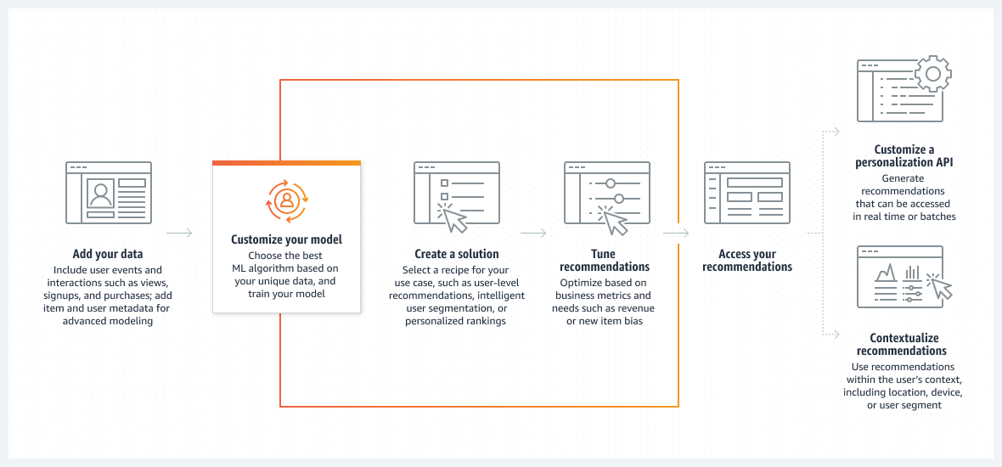

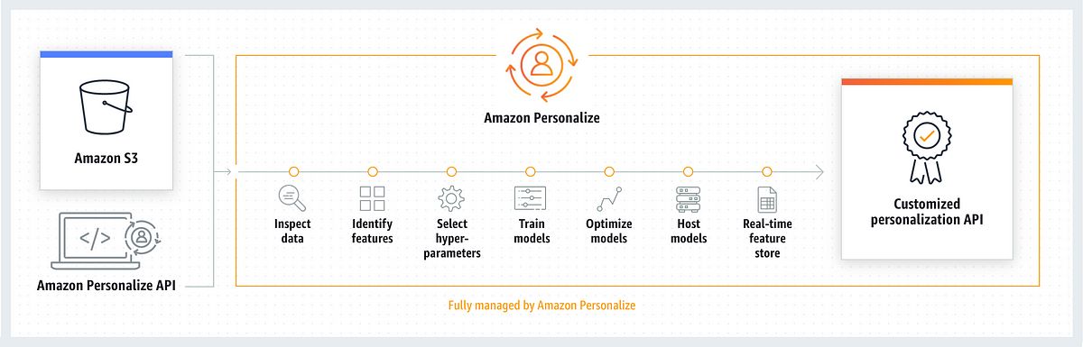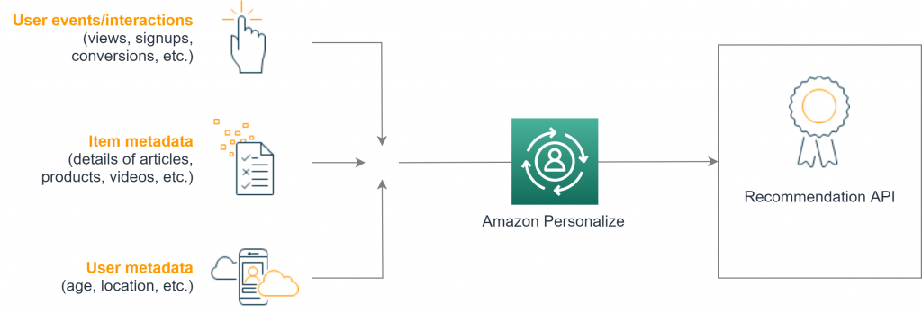

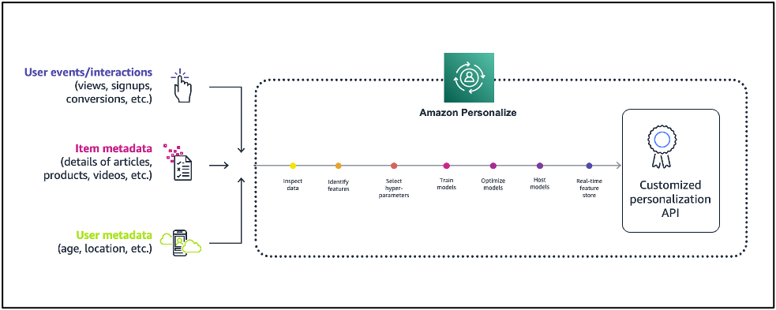

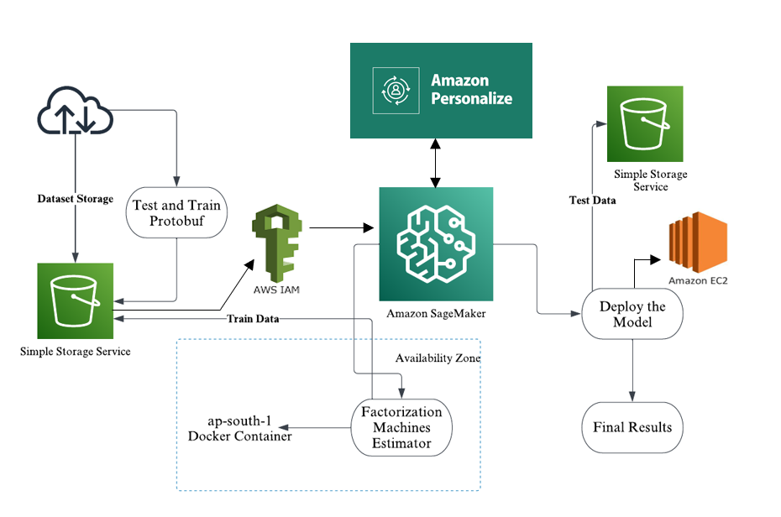

[Harish Sujanmulk](mailto:sujanmulkharwish369@gmail.com)

**Report on existing Content Recommendation System**

**"Revolutionizing Product Recommendations & Review Safety with Amazon Rekognition"**

**In-depth analysis of its features:**

**Revolutionizing Review Safety":** Implementing Amazon Rekognition Content Moderation to safeguard your online marketplace by automatically detecting and removing harmful images from product reviews, ensuring a safer and more inclusive shopping environment for all customers.

**"Enhancing Customer Trust":** By proactively enforcing Amazon Community Guidelines,will maintain the integrity of product reviews, enhancing customer trust and providing accurate information, ultimately driving better purchase decisions and satisfaction.

**"Efficiency & Cost Savings":** Harness the power of content moderation automation with Amazon Rekognition to reduce human review workloads, improve the well-being of moderators, and achieve significant cost savings while upholding the highest standards of review quality and safety.

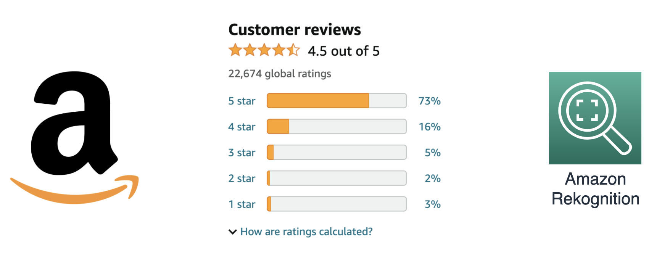

**Algorithms:**

→ **Smart Self-Hosted Moderation: Enhancing Review Safety with Machine Learning**

The context indicates the usage of various models and algorithms as part of the self-hosted ML system. These could involve a range of techniques such as convolutional neural networks (CNNs) for image analysis, natural language processing (NLP) for text analysis, or even ensemble methods for decision-making.

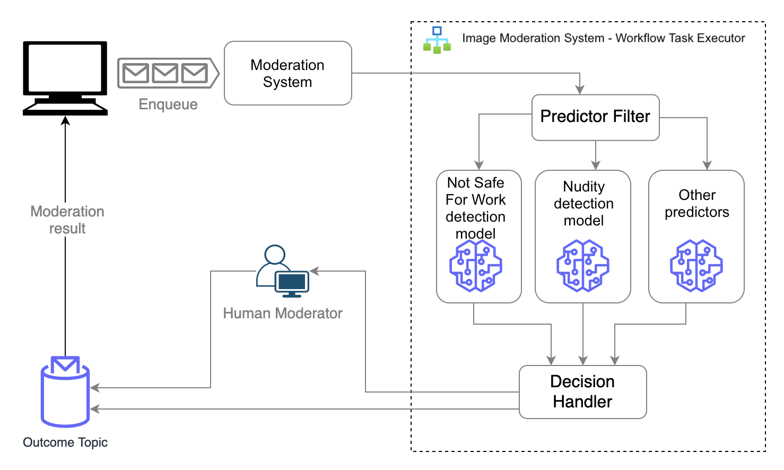

**Enhancing Automation Through Iterative Learning:**

Its focus on improving ML algorithm accuracy demonstrates their commitment to refining models continually. By investing in data labelling, data science, and MLOps, they aim to boost the automation rate, making the review process more efficient and less reliant on manual intervention.

**Architecture:**

---> **Streamlining Content Moderation with AWS Rekognition: Improving Automation and Scaling Efficiency**

**Efficient and Accurate Content Moderation:**

Leveraging Amazon Rekognition's Content Moderation API, the team has achieved high accuracy in detecting inappropriate content across a variety of industries. This automated solution ensures that user-generated content, including product reviews and social media posts, is thoroughly moderated, enhancing user safety and regulatory compliance.

**Streamlined Systems and Cost Savings:**

The migration of self-managed ML models to Amazon Rekognition has not only increased the accuracy of content moderation but has also simplified the system architecture. By automating more decisions with the highly accurate pre-trained models, the team has achieved significant cost savings while maintaining effective content filtering.

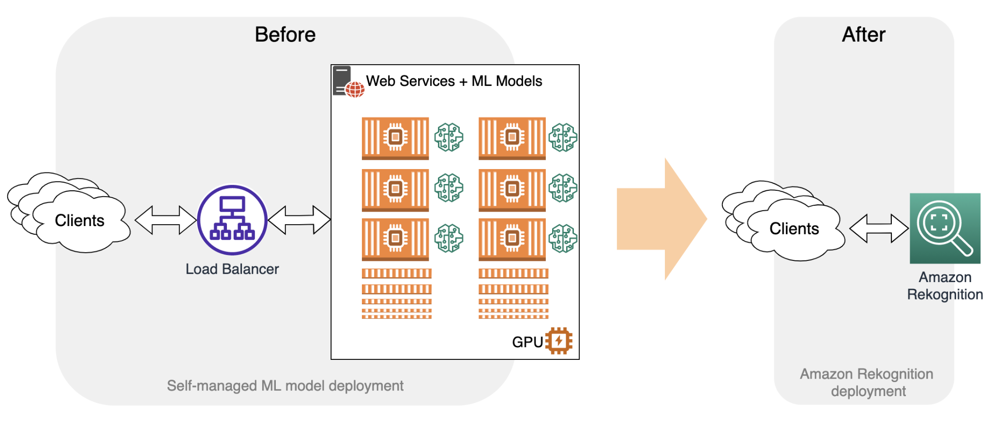

**---> "Achieving High Accuracy in Content Filtering"**

The Amazon Shopping team's simplified architecture has not only reduced operational efforts significantly but also freed up valuable time for innovation. This means more focus on developing exciting features instead of routine maintenance tasks, saving months of DevOps effort each year."

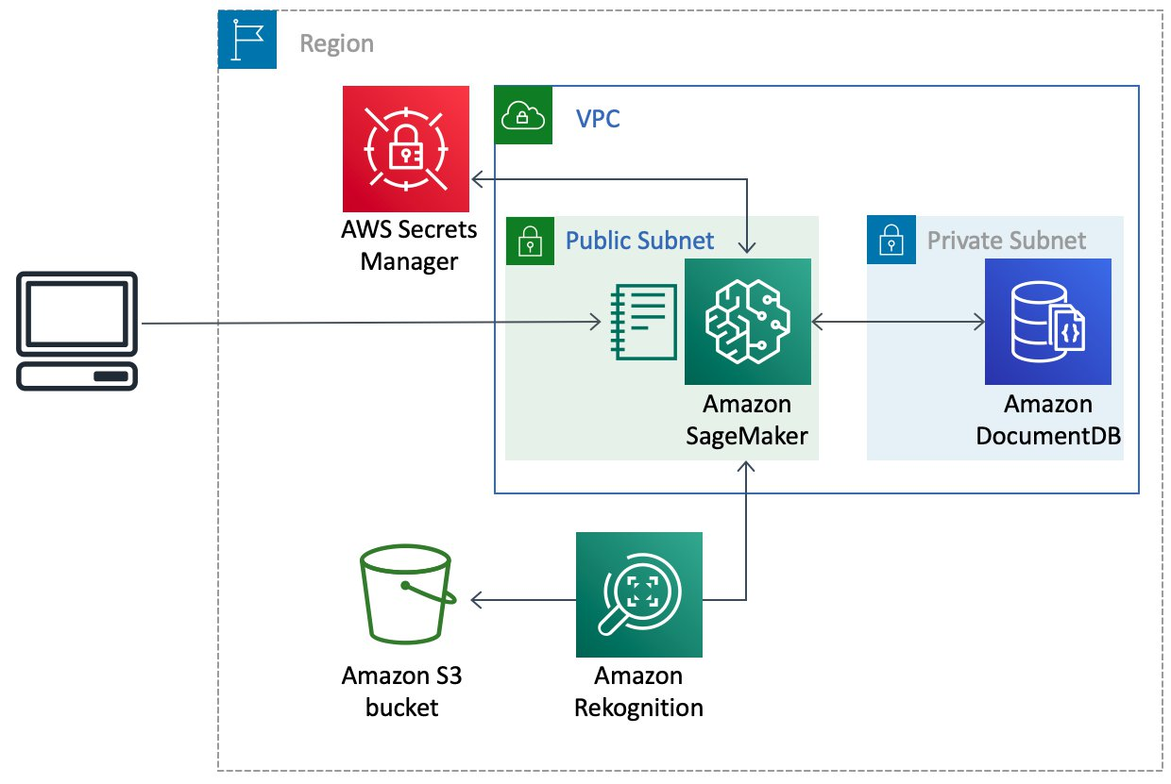

**---> "overall effectiveness of the system"**

"Cutting Costs, Boosting Efficiency: With AWS Rekognition precise content moderation, the team now sends fewer images for human review, slashing moderation expenses. This shift lets moderators concentrate on critical business tasks, leading to substantial savings alongside enhanced operational efficiency from DevOps improvements."

**---> Conclusion**

"Efficient Review Moderation: Switching to Amazon Rekognition API streamlines moderation, ensuring swift, accurate review checks, enhancing customer experience by swiftly removing unsuitable content. This managed service not only saves costs but also eases the technical burden for businesses, offering customizable rules to meet specific requirements."